ECO-CONGREGATION
Ideas for Action

SCOTLAND
an environmental toolkit for churches

An environmental check-up for your church

Welcome to Eco-Congregation Scotland!

This Church Check-Up has been developed to help you get started as an eco-congregation. It will:
- help you identify and affirm the environmental work you are already doing with your congregation, church centre and/or church offices
- give you advice on how to develop and grow as an eco-congregation
- show your areas of strength and those that can be further developed
- point you to help for the areas you want to get involved in.

It is not a test! It is here to help you.

To become an eco-congregation, we recommend you form a small group to work through the check-up and prioritise your next steps. When you have done this, send us your registration form. You can download this, as well as your choice of modules from the website (http://www.eco-congregation.org/scotland/materials.html) or order them from us (address details on the back page). Do distribute the resources to appropriate people/groups in your church (e.g. worship resources to worship leader, property resources to property committee) and encourage them to develop and put into effect your plans.

The environmental check- up

1. CHECK-UP

Use the following sections to identify your church’s current environmental good practice and future priorities. For some questions you may wish to tick more than one box (e.g. an environmental feature may be present but also have the potential to be further developed). There is space for additional notes on each. Skip those sections or tick boxes that aren’t relevant for your church.

2. WORSHIP / LITURGY
Worship is the prime focus of Christian life from which the Church’s life and mission flows. This section is designed to help you identify how thankfulness and concern for God’s creation are expressed in your worship.

How regularly during the year are environmental concerns included in worship?
Never Occasionally Only at special services Frequently
e.g. Harvest Festival,
World Day of Peace
In your Church’s prayer life, do you:
Praise God Say sorry for the Give thanks to God for Pray for the the creator harm done to the the gift of creation healing of environment creation
Does your Church connect with God’s gift of creation through worship?
Through Through prayer Using natural materials Choosing organic
outdoor services walks within worship bread and wine
Does your Church sing hymns or songs that celebrate the wonder of creation and express the calling to care for the environment?
Regularly On special Hardly ever
Sundays
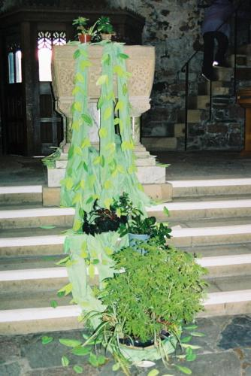
Notes:

Tip: Ideas for Action, “Greening Worship”, contains ideas and resources for worship leaders.

3. THEOLOGY

Theology is concerned with giving and exploring a rational and orderly account of Christian belief, drawing on Biblical studies, Church tradition and history, ethics and the context in which the Church is present.

Does your church: Yes No Has potential to
develop

Have access to Christian environmental resources

Produce resources with environmental themes

Participate in or organise study/exploration events
that include environmental issues?

Include creation/environmental issues in its
teaching, studying and preaching programme?

Notes:
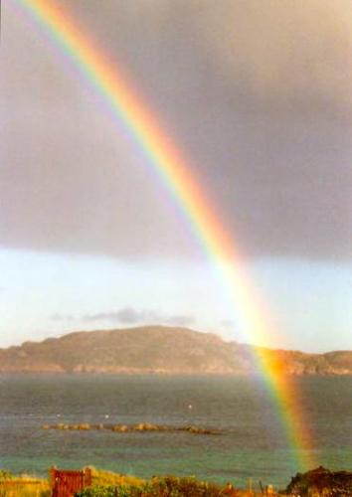
Tip: Ideas for Action, “Theology and the environment”, contains green theological ideas and suggestions for further reading.

4. CHILDREN’S WORK
Christian work with children can inform, inspire and encourage youngsters as they grow in faith.

Does your children’s programme (infant and primary age) include environmental issues and the potential for developing this ministry?

Sometimes Never Has potential to
develop
Junior Church/ Sunday School/ Children’s
Liturgy and Catechism
Uniformed organisations
Playgroups
After school/ holiday clubs
In schools e.g. through Assemblies
All age worship

Notes:

Tip: Ideas for Action, “Children and creation care”, includes inspiration and ideas for incorporating indoor and outside environmental activities in children’s work.

5. YOUTH WORK
Churches undertake a range of youth work including group meetings on Sundays, church and open youth groups and mid-week uniformed organisations. If your church undertakes youth work, you can review your existing activities and consider future possibilities here.

Activities Have done Could consider
Involve young people in auditing and improving the
environmental management of the premises
Hold a debate on environmental issues and
personal responsibility
Develop creation-care material to offer in worship
Undertake a practical environmental/conservation project
Arrange a ramble(s)
Organise an environmentally focused community event (with
young people from the whole community)

Notes:

Tip: Ideas for Action, “Young people and the environment”, has ideas and activities for youth work.

6. ALL-AGE EDUCATION
Church is a place where people can grow in faith from cradle to grave. Relating key topics, like environmental issues, with Christian thinking can be inspirational and faith-affirming.

What opportunities are or could be available for your church?

Activities Have done Could consider
Undertake an environmental Bible study/ Reflection
Invite a speaker on environmental issues
Organise/ participate in a creation-care Lent group
Produce study material on environmental issues
Notes:



Tip: Ideas for Action, “Resources for small groups”, includes two sets of Bible studies and an address suitable for house groups or sermon preparation.

7. CHURCH PROPERTY
Good stewardship of energy and maintenance issues can both reduce your Church’s impact on the environment and save your Church money, particularly in the long-term. This section can help you to assess your churches current environmental stewardship of property (sanctuary, halls, clergy housing) and the potential for developing this.

Have done Could consider
Insulate church buildings wherever possible
Choose appropriate sized rooms for activities
Timetable meetings to minimise heating use
Heating system with timer and thermostatic controls
Fit energy saving light bulbs
Encourage building users to switch off unnecessary
lights and not leave items on stand-by (e.g. photocopier)
Check water outlets – fix drips and leaks
Install water-saving devices (e.g. dual flush toilets and
low spray flow or auto turn-off taps)

Notes:

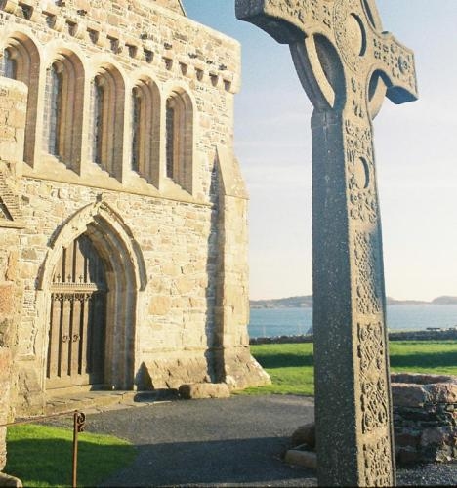

Tip: Ideas for Action
“Greening church buildings”, includes ideas and sources of resources to help churches to put God’s house in green order.
“Managing your carbon footprint” offers help with managing your energy use.

8. CHURCH MANAGEMENT
Churches are responsible for the good stewardship of money and a range of consumables. You can use this section to assess your church’s existing good practice and identify issues for consideration and action.

Purchasing policy & financial management
Have done Could consider
Purchase Fairtrade products (e.g. tea and coffee)/
become a Fair trade Church/ Parish

Use local suppliers where possible (promoting a
sustainable local economy and reducing transportation)
Use environmentally-friendly cleaning materials & paint
Purchase recycled paper and envelopes
Check the environmental policy of your bank and see
if you are satisfied with it
Have an ethical investment policy for any savings/
enquire about this at the appropriate church body

Catering
Use crockery rather than disposable cups and plates
Use farmers markets and other local suppliers (to promote
local economy and reduce food miles)

Waste minimisation
Collection facilities for recycling items which can be used by
church members, building users or local community (e.g. paper,
cans, spectacles, stamps, printer cartridges, clothes, shoes, foil)
Hold jumble sales to raise funds, recycle goods and promote
the availability of goods at affordable prices

Notes:
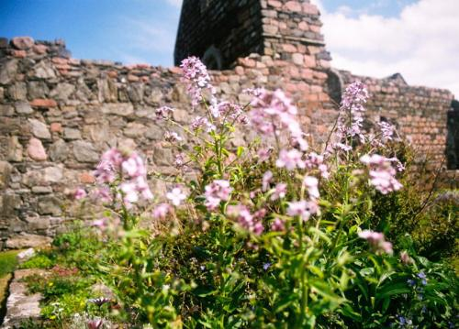
Tip: Ideas for Action, “Greening church spending”, includes ideas for
good stewardship of financial, catering and purchasing matters.

9. CHURCH LAND
Many churches are responsible for land varying in size from a tiny patch to a large acreage. This section can help you to assess the ecological value, value to the community and attractiveness of your church’s plot and the potential to develop it.

Present Potential to develop
Wildlife-friendly management (e.g. minimal use of
weed killers and pesticides, leaving some areas to grow,
valuing old trees, hedges, walls and stones)
Native plant species and plants that benefit wildlife
(e.g. flowers used by moths and butterflies, berry-bearing
trees for birds, hawthorn and blackthorn)
Other features to benefit wildlife (e.g. bird feeding station,
bird nest boxes, bat boxes, piles of leaves and rotting logs
for insects and hedgehogs)
Visually attractive planting/ features
Area for prayer/ contemplation/ outdoor worship
Area for recreation

Notes:


Tip: Ideas for Action, “Churchyard conservation”, offers inspiration and resources
for churches to assess the ecological value of their land and develop a
management plan and to improve the community benefit or wildlife value of the plot.

10. PERSONAL LIFESTYLE
More people attend church week by week than participate with any other voluntary body. You can use this section to assess what your church is currently doing to encourage individuals to green their lifestyle and the potential to develop this mission.

Have done Could consider
Publish green tips in a church/ parish magazine/ bulletin
Promote awareness through posters or information from
environmental organisations (e.g. home energy audit)
Encourage recycling by providing collection points or
informing people of civic facilities
Encourage walking and cycling to church

Notes:

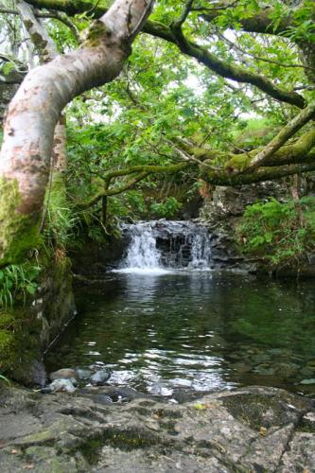

Tip: Ideas for Action, “Lifestyle issues”, includes information and tips to green lifestyles.

11. COMMUNITY OUTREACH
Churches can work with and through their local community to improve their neighbourhood. Here you can assess the links that your Church already has in the local community and the potential for further development.

Have done Could consider Establish links with community organisations with a
view to sharing your environmental ministry
(e.g. schools, youth groups, local environmental bodies)
Advise building users of your environmental concerns
and request that they utilise any environmental facilities
Participate in local environmental initiatives or policy
formation – Local Authorities can advise
Draw on links that members have with environmental
bodies (e.g. Friends of the Earth, Wildlife Trust, RSPB)

Support or initiate community schemes with a positive
environmental element (e.g. Clean-up, LETS, Credit Union)

Notes:
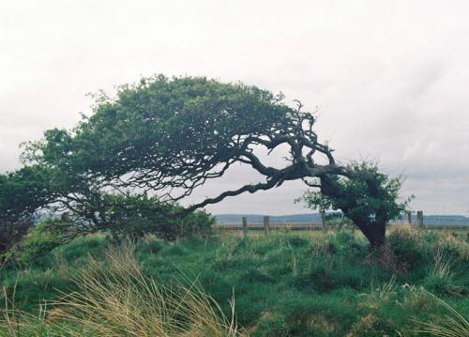
Tip: Ideas for Action, “Community matters”, includes stories, ideas and
contacts for undertaking work with and through local communities.

12. OVERSEAS CONCERNS

Living simply that others may simply live is a facet of Christian life.

What can your church do to benefit the environment and people across the world?

Have done Could consider Support the work of Christian development agencies
(e.g. Christian Aid, SCIAF)
Have an active Justice and Peace group
Initiate or participate in activities in One World Week
Promote Fairtrade
Explore environmental issues through linked overseas
communities or churches
Support the work of international conservation and
environment agencies (e.g. A Rocha, WWF, Friends of the Earth)

Notes:

Tip: Ideas for Action, “Global neighbours”, includes ideas and contacts to help churches
to think and act locally to promote environmental care globally.

13. CLIMATE CHANGE
Climate change poses a serious and immediate threat to people everywhere, particularly to the poor of the earth. This section can help you to identify what you can do in your church buildings and in your daily lives to reduce your carbon footprint.

Have done Could consider Read your meters regularly/ assess your energy usage
Calculate the carbon footprint of your buildings

Take steps to reduce your carbon footprint
Encourage the congregation to reduce their carbon
footprint in their everyday lives

Notes:


Tip: Ideas for Action, “Managing your carbon footprint”, enables you to calculate the carbon footprint of your church buildings and at home and to take steps to reduce it.

CONGRATULATIONS on all the work your church is already doing to care for the Earth! Now use the following pages to summarise your achievements so far and to draw up an Action Plan

SUMMARY

List here what your church is already doing to care for creation

SPRITUAL LIVING - Worship and prayer, theology and bible study, teaching for young and older people:

PRACTICAL LIVING - in the church buildings, grounds and in your use of resources:

GLOBAL LIVING - in personal lifestyle choices, in your community and the wider world:

NOW use the table below (or make up your own one) to draw up your

ECO-CONGREGATION ACTION PLAN

ACTION | TIMESCALE | WHO


For further information contact:

Eco-Congregation Scotland
121 George Street, Edinburgh, EH2 4YN
E scotland@ecocongregation.org.uk | T 0131 240 2274

Website www.ecocongregationscotland.org
Blog www.ecocongregationscotland.blogspot.com ALL PHOTOS © ANIKÓ SCHUETZ
Facebook www.facebook.com/ecocongregationscotland
Twitter @ecocongregation

Eco-Congregation Scotland is a Scottish Registered Charity, No. SC041287
and a Company Registered in Scotland, No. SC372366.

