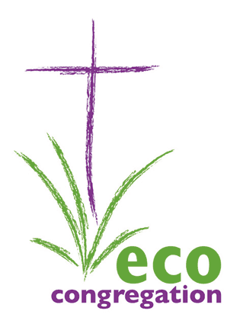
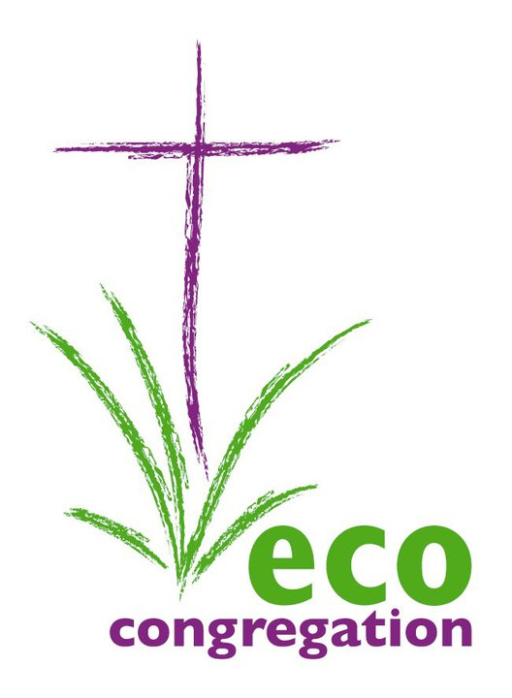
Eco-Congregation Scotland
Annual Gathering
Saturday 21st April 2012
10am – 4pm

Bridge of Allan Parish Church Halls
Keir Street, Bridge of Allan, FK9 4NW
REGISTRATION FORM

NAME

CONGREGATION/
ORGANISATION

POSITION (if applicable)

EMAIL ADDRESS /
POSTAL ADDRESS

TELEPHONE

SPECIAL DIET

OTHER SPECIAL NEEDS
(e.g. wheelchair access, loop system, etc)

WORKSHOPS - please choose two from the list below

There is no booking fee for the conference; however, a contribution of £10 will be invited, to help us to cover costs. You can give your donation at the event or post it to our address.
We will contact you with any changes to the itinerary and to confirm your registration and workshop choices with you.

PLEASE RETURN THIS FORM, BY 15th MARCH 2012
oanshus@cofscotland.org.uk or Eco-Congregation Scotland, 121 George Street, Edinburgh EH2 4YN
For further information, please email oanshus@cofscotland.org.uk or see our website http://www.ecocongregationscotland.org/events/
Annual Gathering programme
10:00 Registration tea/coffee
10:30 AGM
11:00 Stewart Stevenson MSP Keynote Address
11:20 Plenary discussion: ‘How can congregations help promote behaviour change?’
11:45 Worship
12:00 Lunch
12:45 Workshop Session 1
13:45 Workshop Session 2
15:00 Closing discussion

Workshop information
There are 6 workshops. They will all run twice to enable you to take part in two of them. To ensure there is enough space in each workshop we ask you to number them from 1 to 6 them in accordance to your preference (Your first choice is 1 and least preferred option is 6):

Malcolm Rooney, minister at Kirriemuir, will lead a workshop promoting behaviour change to tackle climate change issues in presbytery

Dane Sherrard, minister at Luss, will lead a workshop on green pilgrimage.

Andrew Faulk of Consumer Focus will look at the financial support available to congregations, including details of the new ‘green deal’.

Christian Aid and SCIAF will jointly lead a workshop on climate justice and International development.

Charles Agoboklu of the Evangelical Presbyterian Church and interfaith climate change network of Ghana will tell us how churches in Ghana are helping people respond to climate change.

The Green Team of the Scottish Government will lead a workshop on the Climate Challenge Fund and the opportunities it offers congregations.

We will contact you with any changes to the programme and to confirm your registration and workshop choices with you.

