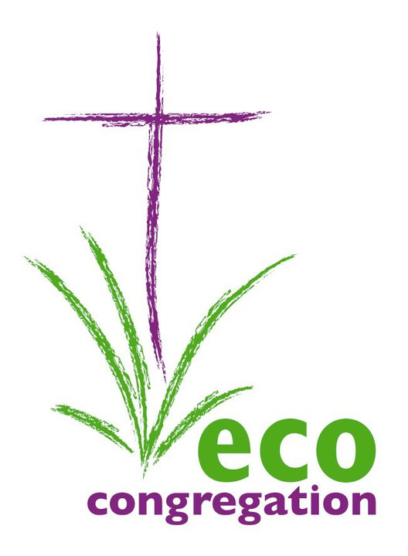
Gift Aid Declaration : ECO-CONGREGATION SCOTLAND

Please treat

…… The enclosed gift of £…………… as a Gift Aid donation; OR

…… All gifts of money that I make today and in the future as Gift Aid donations; OR

…… All gifts of money that I have made in the past 6 years and that I make today and in the future as Gift Aid donations.

Please put a cross “X” alongside the selected option.

You must pay an amount of Income Tax and/or Capital Gains Tax for each tax year (6 April one year to 5 April the next) that is at least equal to the amount of tax that ECO-CONGREGATION SCOTLAND will reclaim on your gifts for that tax year.

Donor’s details

Title …………… Initial(s) …………...............….. Surname ………..............................………………………….

Home address ………………………………………………………………………………...................................................

City or Town ….………………………………………..… Postcode ….............................................…………………

Date ……………………….................................….. Signature …….................…………………………………………

Notes

Please notify ECO-CONGREGATION SCOTLAND if you:
- Want to cancel this declaration.
- Change your name or home address.
- No longer pay sufficient tax on your income and/or capital gains.

ECO-CONGREGATION SCOTLAND will reclaim 25p of tax on every £1 you give.

If you pay income tax at the higher rate, you must include all your Gift Aid donations on your Self Assessment tax return to receive the higher rate tax relief due to you.

