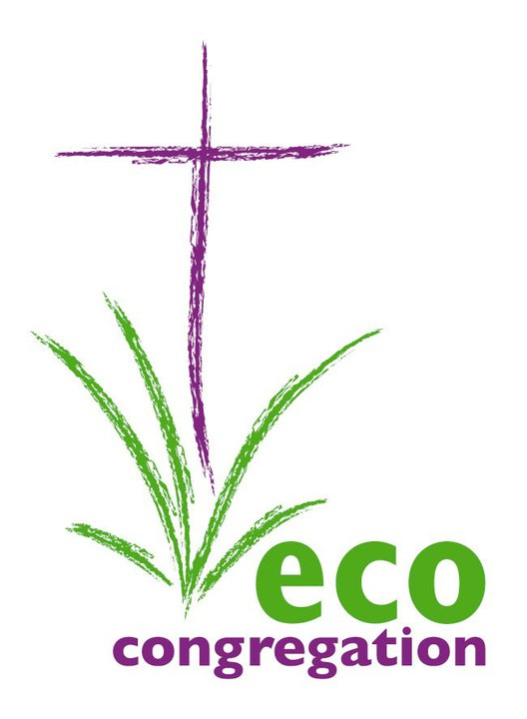
Eco-Congregation Scotland Annual Gathering 2012
Saturday 18th April 2012, Bridge of Allan Church
FEEDBACK FORM

Please take a few minutes to complete this form and return it to the organisers today or post it or email the form to us within the next week:
Email: oanshus@cofscotland.org.uk
Postal Address: Eco-Congregation Scotland, 121 George Street, Edinburgh EH2 4YN.

1. How successful was the Annual Gathering in meeting your expectations? (circle option)
Poor / Average/ Good/ Excellent
Additional comments:

2. Are there ways in which you think the Annual Gathering could have been improved?

3. What did you think of the lunch/refreshments? (circle option)
Poor / Average/ Good/ Excellent
Additional comments:

4. Would you be interested in receiving email uptakes from Eco-Congregation Scotland? (Tick appropriate boxes)
*Eco-Congregation Scotland News
*Eco-Congregation Scotland Blog

*If you register to receive updates your information will be held on a secure server and the data will not be shared with any other organisations. It will be used only to provide you with information from Eco-Congregation Scotland.

5. What workshops did you attend? (Tick box)
How successful were they in meeting expectations? (Circle option)

Malcolm Rooney Poor / Average/ Good/ Excellent
Charles Agboklu Poor / Average/ Good/ Excellent
Andrew Faulk Poor / Average/ Good/ Excellent
The Green Team Poor / Average/ Good/ Excellent
Dane Sherrard Poor / Average/ Good/ Excellent
Christian Aid/SCIAF Poor / Average/ Good/ Excellent
Additional comments:

6. Do you have any workshop suggestions for next year?

7. Do you have any suggestions on suitable for suitable Annual Gathering venues for next year (must have space for 150)?

8. Any other comments:

Please provide us with your contact details:
Name:
Email/ other contact address:
Many thanks!

