Eco‐Congregation Scotland
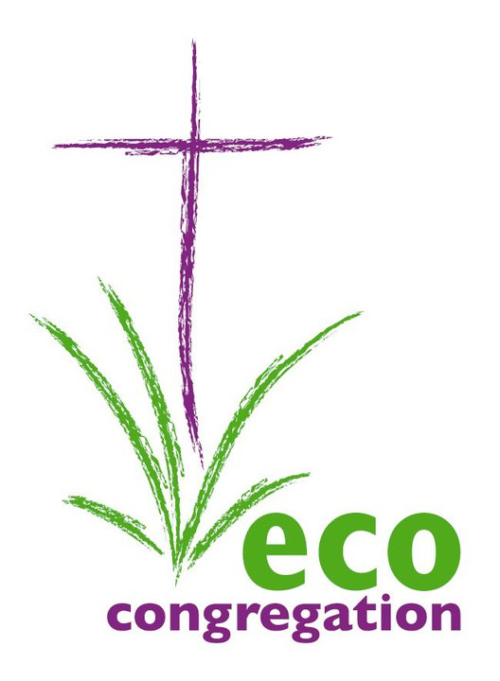
Annual Gathering
Saturday 20th April 2012
10am – 3.15pm
Grassmarket Community Project Hall

REGISTRATION FORM

NAME

CONGREGATION/ORGANISATION

POSITION (if applicable)

ADDRESS (email or postal)

TELEPHONE

SPECIAL DIET

OTHER SPECIAL NEEDS
(e.g. wheelchair access, loop system, etc)

WORKSHOPS please read workshop details on the next page. Choose two workshops from the list below
The Nourish project | Just Eating? | The Global Food Crisis
Enough Food IF | Café Conversation | Funding for environmental projects

I would like to attend the following workshops:

Please return this form by 4th April 2013. Please email or post it to:
Email: oanshus@cofscotland.org.uk
Postal address: Oyunn Anshus, Eco‐Congregation Scotland,
121 George Street, Edinburgh, EH2 4YN

For further information, please email oanshus@cofscotland.org.uk or see our website www.ecocongregationscotland.org/events/

Annual Gathering programme
10am Registration tea/coffee 1pm Workshop Session 1
10:30 Worship 2pm Workshop Session 2
10:40 AGM 3pm Closing discussion
11am Rev David Atkinson
11:20 Rev Liz Henderson
11:40 Plenary discussion
12pm Lunch Finish at 3:15pm

There is no booking fee for the conference; however, a contribution of £10 will be invited, to help us to cover costs. You can give your donation at the event or post a cheque to our address. Please make cheques payable to Eco-Congregation Scotland. We can also accept donations by BACS. Please contact us if you would like to do this.

Workshop information

There are 6 workshops. They will all run twice to enable you to take part in two of them. Congregations are asked to bring something to share in the Café Conversations workshop. If you have anything you would like to display please bring it with you so people can see it at lunch time. We have extended lunch to allow for this and may have some display stands from other organisations.

Please choose two you would workshops you would like to attend:

The Nourish project - Pete Ritchie, an organic farmer, will talk about his experience of getting local people involved in running his farm

Café Conversation - an opportunity to sit round a table and share your church’s environmental projects with other congregations, especially if they relate to food
*Please bring examples of your work if you have them*

Enough Food IF – Christian Aid and SCIAF presents the biggest mass campaign movement fighting poverty since Make Poverty History and explains how you can become involved

Funding for environmental projects – The Scottish Government’s Climate Challenge Fund and Community Energy Scotland will present what funding they have available for local community projects and how churches can apply

Just Eating? – Presentation about a study programme published by the Presbyterian Church USA. A representative of a Scottish Eco-Congregation who has used these study materials will show how it works and explain what they have gained from it.

The Global Food Crisis - Where will our food come from in the future? Dr Neil Hollow has recently completed a doctorate in Environmental microbiology. He is co-author with Andy Mellen of “No oil in the lamp: Fuel, faith and the energy crisis" published by DLT which is written to alert Christians to the challenges of peak oil and the coming global energy crisis.

We will contact you with any changes to the programme and to confirm your registration and workshop choices with you.

