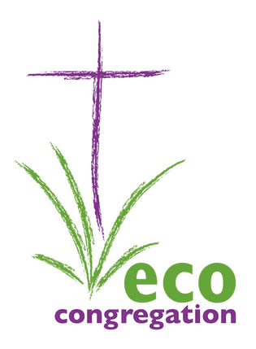

Highland Eco-Congregation Network

REGIONAL GATHERING

Saturday 26th April 2014

11.00am – 3.00pm

Ness Bank Church

Inverness

BOOKING FORM

Your name:

Church or organisation:

Other members of your congregation who are coming with you:

1.

2.

3.

4.

5.

Everyone is welcome! Please add any more names below, as appropriate!

Is your church registered as an Eco-Congregation? See:
http://www.ecocongregationscotland.org/about-us/list-of-eco-congregation-churches
if you are not sure! YES / NO

This event is free but we ask that you bring your own sandwiches etc for lunch, teas, coffees and a bowl of soup will be provided. Please let us know if you, or any in your party, have any special dietary (or other) requirements:

PLEASE RETURN THIS FORM BY MONDAY 14TH MARCH to
margaret@ecoccongregation.org.uk

