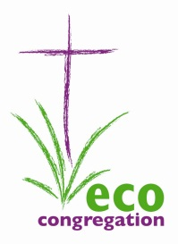 **Eco-Congregation Scotland**

18th August 2014

Dear

**“The Environment – a Christian Imperative?”**

The Dumfries and Galloway Eco-Congregation Network invites you to an event that it is jointly organising with Eco-Congregation Scotland on 10th September, 7.30pm in Dumfries North West Church, Lochside Road, Dumfries DG2 0DZ. The talk is open to everyone but might be of particular interest to Ministers, Pastors, Priests, Session Clerks, Vestry Secretaries and laity with responsibilities for Mission and Chairs of Boards.

The Rev Trevor Jamison of the United Reformed Church has been appointed as Environmental Chaplain for Eco-Congregation Scotland, a post supported by the URC. He will be talking about the Environmental Imperative for Christians, and how care for creation can help churches to become more involved with their community and with the wider world.

At a time when all churches are facing huge challenges and pressures with rising costs and shrinking congregations, is environmental concern a luxury we cannot afford? Or might it just be part of the solution? The meeting will pose the challenge: “Can caring for creation help care for the Church?”

Trevor will speak for about 40 minutes followed by questions and discussion. The evening will finish by 9.00 pm with a cup of tea.

If you are able to come, (and feel free to bring others with you) please RSVP by email to me at: [margaret@ecocongregation.org.uk](mailto:margaret@ecocongregation.org.uk) or call me on 01877 330182.

If you are unable to come yourself, please feel free to pass on this invitation to someone else in your congregation or locally who might be interested.

Yours sincerely,

Margaret Warnock

Co-ordinator

Eco-Congregation Scotland