Contact:  Phone  Email: | Insert your contact details | Insert name of your Parish Church

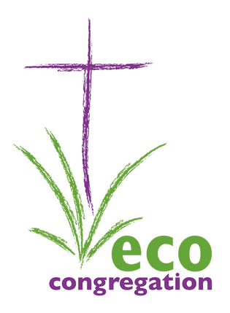
Press Release

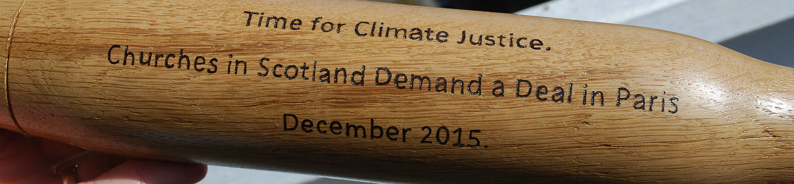
Climate Justice Baton tours local churches

NAME OF GROUP carried the climate justice baton NAME OF LOCATION/DATE

The baton, made from recycled wood, carries the inscription - Time for Climate Justice. Churches in Scotland Demand a Deal in Paris December 2015.The baton was sent on its way at the Eco-Congregation Scotland (ECS) Annual Gathering by Climate Change Minister, Dr Aileen MacLeod on 25th April.

NAME OF ORGANISER said: “At the beginning of December in Paris over 190 countries will meet to attempt to negotiate a deal on climate change to limits emissions from developed countries and help developing countries adapt to the impact of climate change and develop low carbon economies. The burden of climate change often falls most heavily on the poorest in the world, those who have done least to cause it.”

Notes for Editors:-

- Eco Congregation Scotland is a Charity, offering a programme to enthuse and equip churches to weave environmental issues into their life and mission in an enjoyable and stimulating way. http://www.ecocongregationscotland.org/
- Time for Climate Justice is a global movement including the World Council of Churches and Christian Aid.

Engaging local media: Please try to get a group photo of smiling faces with someone holding the baton, then send it to your local paper along with the press release. Or, please invite your local paper to send a photographer to your event. If there is a someone who you think would be attract interest carrying the baton eg. a politician, footballer, then please alert the local paper. They may come to the event to interview them.

Also, please use the power of twitter to share photos of the event. Use the hashtag #cop21baton

