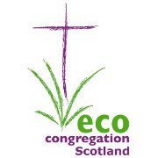
Donation Form

Please make your cheque payable to
“Eco-Congregation Scotland”
and return this form by post to:

Eco-Congregation Scotland
121 George Street
Edinburgh
EH2 4YN

Name
Address
Postcode
Telephone Number
Email Address
This is required so we can send you a receipt.

Donation Amount | £
Gift Aid  I am a UK tax payer and would like Eco-Congregation Scotland to treat all donations I have made over the past four years and all donations I make in the future (unless I notify you otherwise) as Gift Aid donations. I understand that if I pay less Income Tax and/or Capital Gains Tax than the amount of Gift Aid claimed on all my donations in that tax year it is my responsibility to pay any difference. | ❒ Yes  No  Please read Gift Aid notes on next page.
Newsletter  Please keep me informed about your work via the monthly email newsletter. | ❒ Yes  No

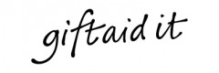
If you are a UK tax payer, the value of your gift can be increased by 25% under the Gift Aid scheme. This means we will be able to claim an additional 25p from the Government for every £1 you donate at no extra cost to you! (See Gift Aid notes below).

Please notify Eco-Congregation Scotland if you want to cancel this declaration; change your name or home address or no longer pay sufficient tax on your income and/or capital gains.

If you pay Income Tax at the higher or additional rate and want to receive the additional tax relief due to you, you must include all your Gift Aid donations on your Self-Assessment tax return or ask HM Revenue and Customs to adjust your tax code.

Signature

Please return this form with your cheque to:
Eco-Congregation Scotland, 121 George Street, Edinburgh, EH2 4YN

If you would prefer to make a regular monthly donation
please visit our web site:

www.ecocongregationscotland.org/donate

