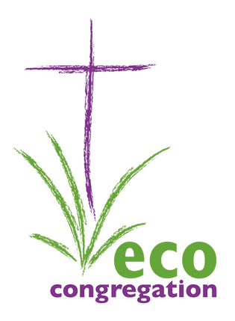
Highland Eco-Congregation Network
18th April 2016, 7.30 – 9.00pm
Barn Church, Culloden

Note of Meeting

Present: Anne Thomas Hilton Church, Inverness
Julie Gibson Inverness Quakers
Richard Mansfield Barn Church, Culloden
Iain Macdonald Trinity Church, Inverness
Duncan Cromb Urray and Kilchrist Church
Trevor Escott Ness Bank Church, Inverness
David Bethune Eco-congregation Scotland
Trevor Jamison Eco-congregation Scotland
Gavin (and carer Laura), Barn Church, Culloden

Apologies: Fiona Smith Ness Bank Church, Inverness
Alice Allan Kilmorack and Erchless
Carola Smith Elgin St.Giles

- Welcome and introductions
David welcomed everyone, opened with prayer, then asked each person to introduce themselves briefly

- Dominion – a dirty word?
Trevor Jamison introduced the topic with a reading from Genesis ch.1, leading us to think about our reaction to, and feelings about, the word “Dominion” in that passage. This led to an interesting discussion about how we read the bible, and the importance of the context – our own background and views, and the historical context of the writer. Trevor invited us to also consider several other passages which make clear that dominion should involve responsibility, including Psalm 24, Revelation 21, John 3v16, Mark 12v29-31, 1 Corinthians 13. The key question for us is: We have dominion, but how are we going to use it?

- Programme 2016 -17

David outlined the need to develop the autonomy of the network groups, by identifying a coordinator and supporting planning group. All agreed to give this some thought, and to get back to David with suggestions for how to make this work.

The possibility of a joint mini-gathering with the Moray network in early 2017 was considered. David will liaise with the Moray network and report back.

A showing of the film “This Changes Everything” at Hilton Church in September / October 2016 was suggested. David to liaise with Anne Thomas to see if this can be arranged.

- Close
Trevor closed with a prayer.

DB 160419

